**Linux commands**

**Update and Upgrade System**

* sudo apt update: Updates the package list.

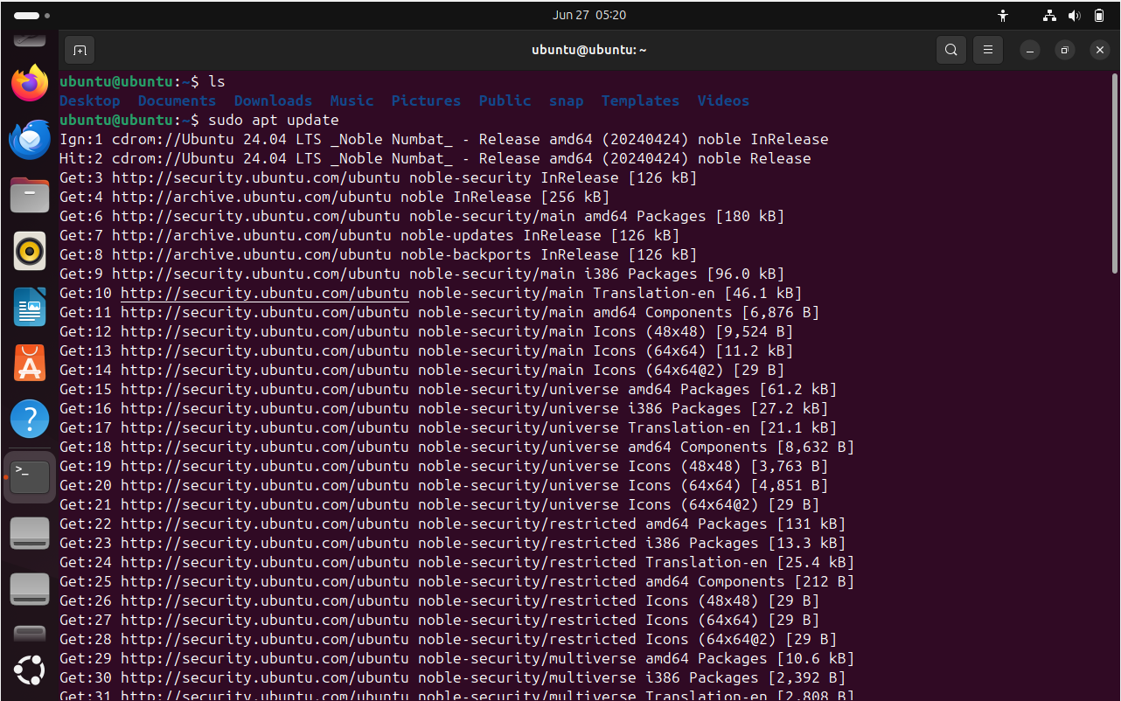

* sudo apt upgrade: Upgrades all the packages to their latest versions.

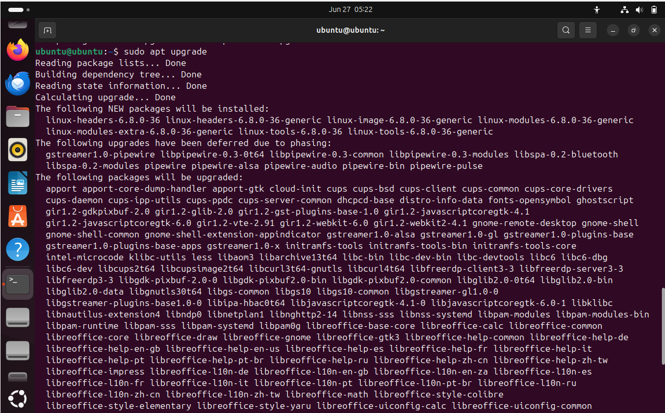

**File and Directory Management**

* ls: Lists files and directories.
* cd [directory]: Changes the current directory to [directory].
* pwd: Prints the current working directory.
* mkdir [directory]: Creates a new directory named [directory].
* rm [file]: Removes a file.
* rm -r [directory]: Removes a directory and its contents recursively.
* cp [source] [destination]: Copies files or directories.
* mv [source] [destination]: Moves or renames files or directories.

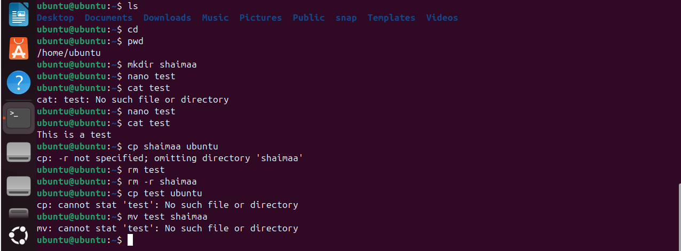

**File Viewing and Editing**

* cat > [file]: create new file and input a text
* cat [file]: Displays the contents of a file.

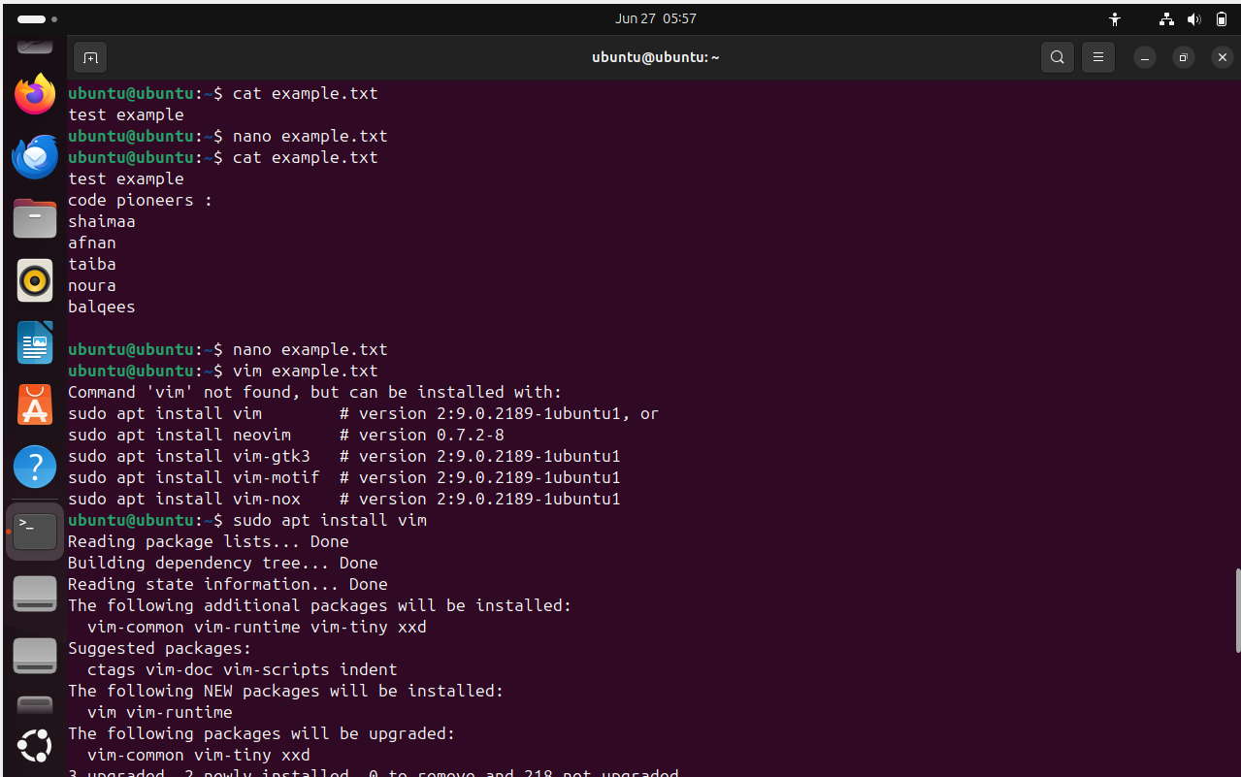

* nano [file]: Opens a file in the Nano text editor. To save it do: ctrl S and ctrl X to exit editor.

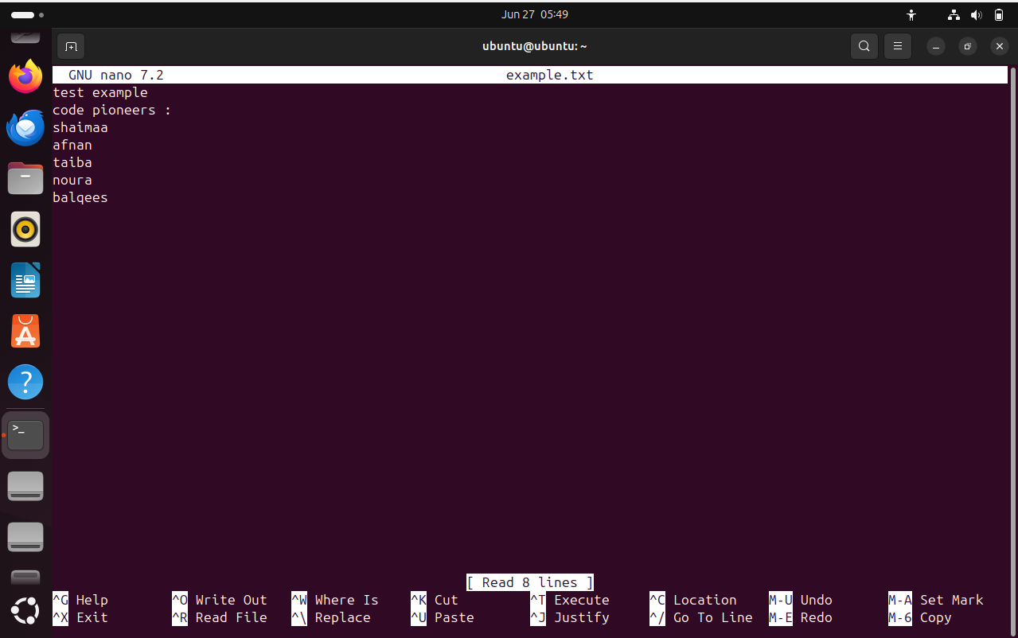

* vim [file]: Opens a file in the Vim text editor. To save it and exit do: go down and type :wq

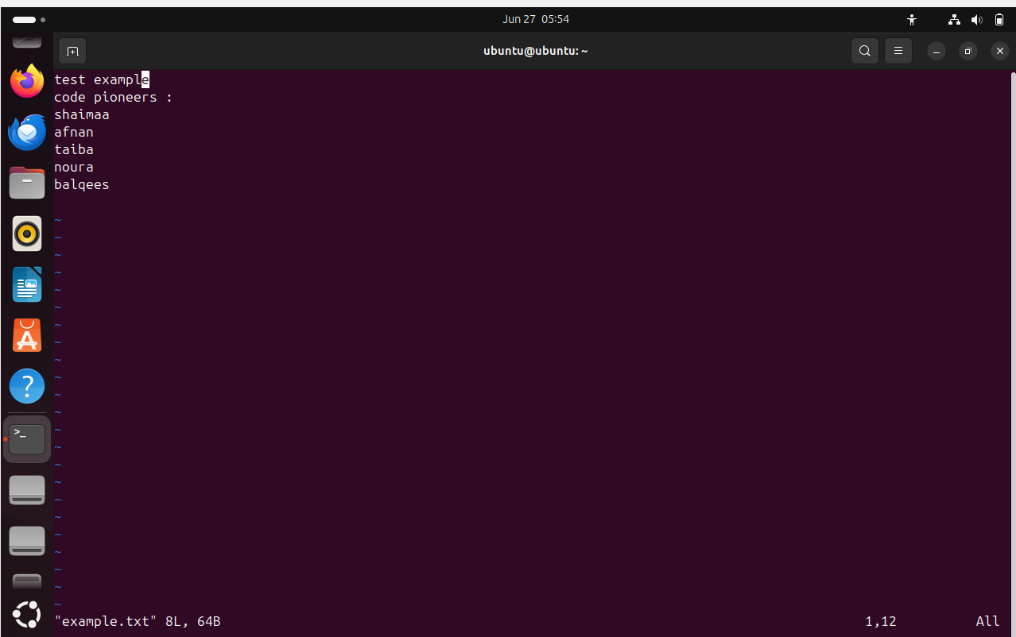

* less [file]: Views the contents of a file page by page. To exit type q.

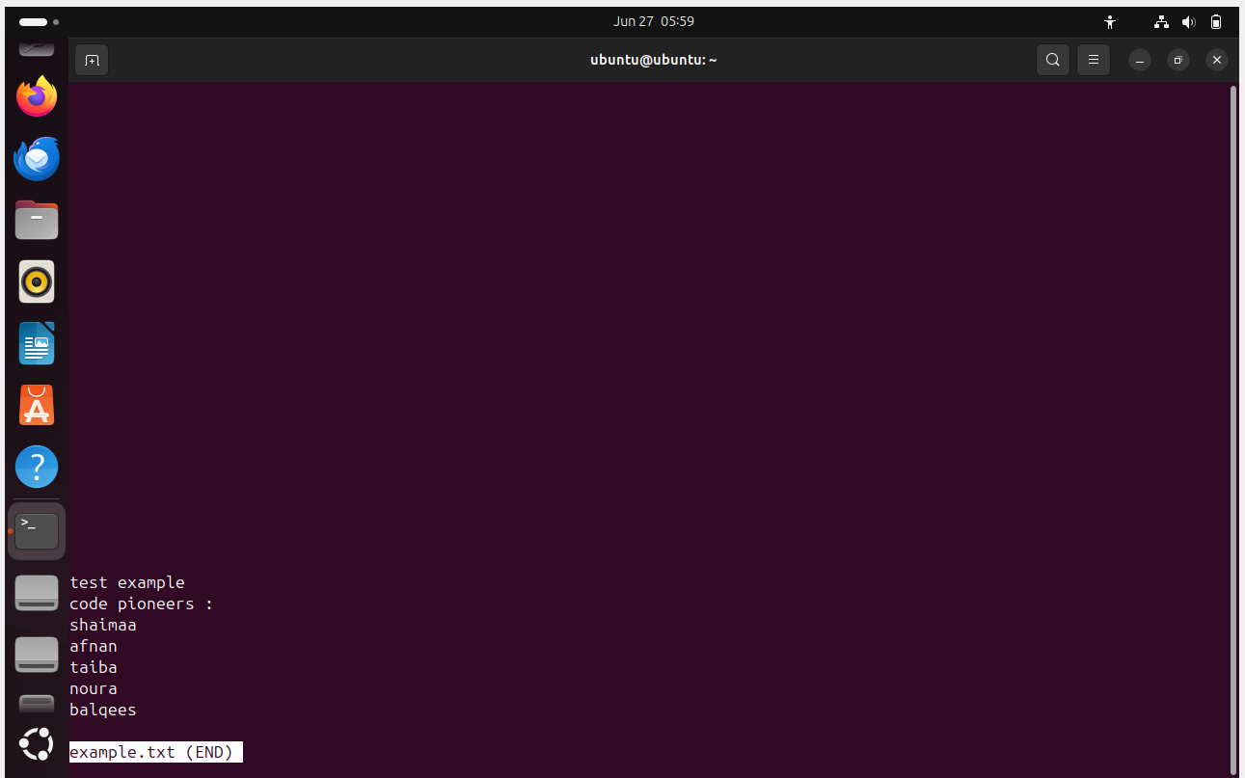

**System Monitoring**

* top: Displays real-time system information including processes.

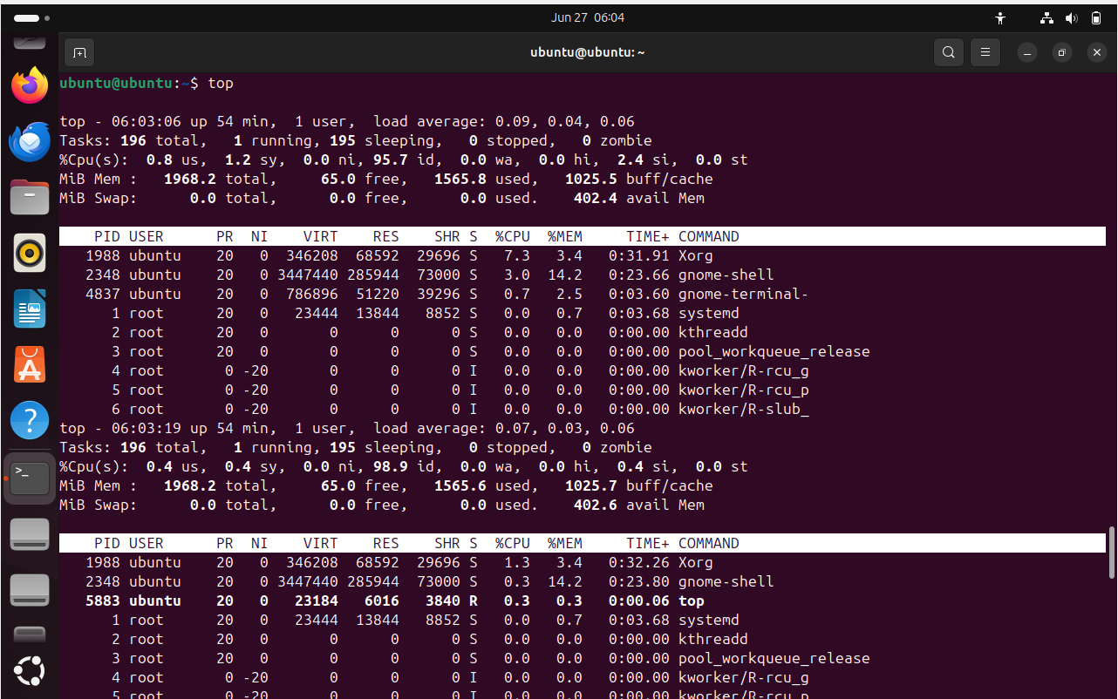

* htop: An enhanced version of top (may require installation).

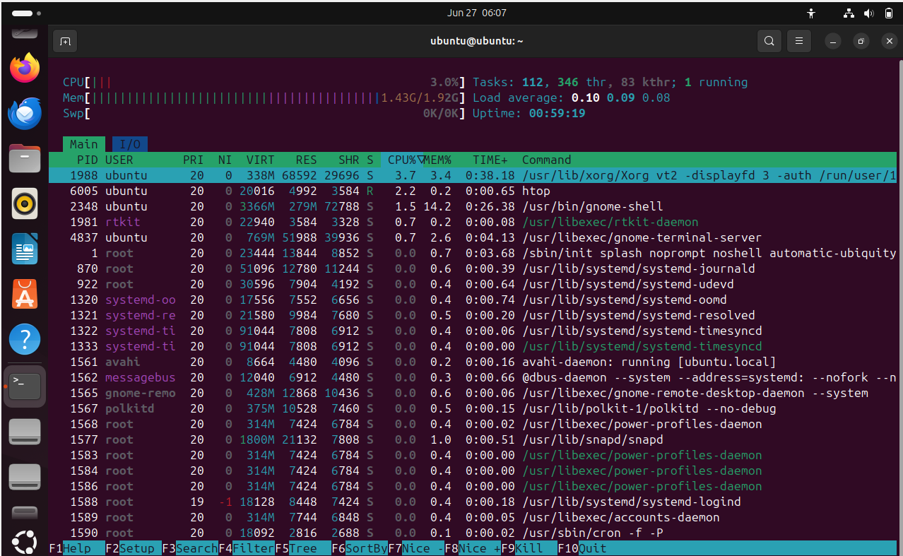

* df -h: Shows disk space usage.

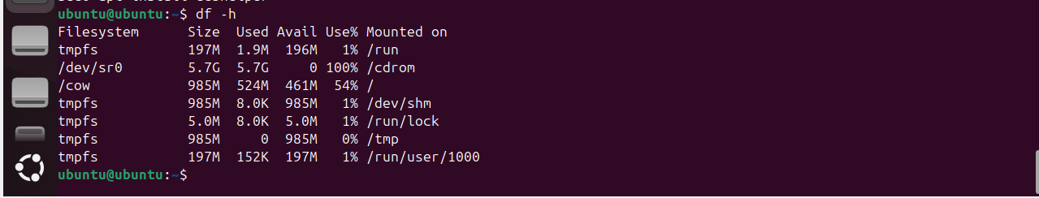

* du -sh [directory]: Shows the size of a directory.



**User Management**

* adduser [username]: Adds a new user.
* deluser [username]: Deletes a user.
* passwd [username]: Changes the password for a user.

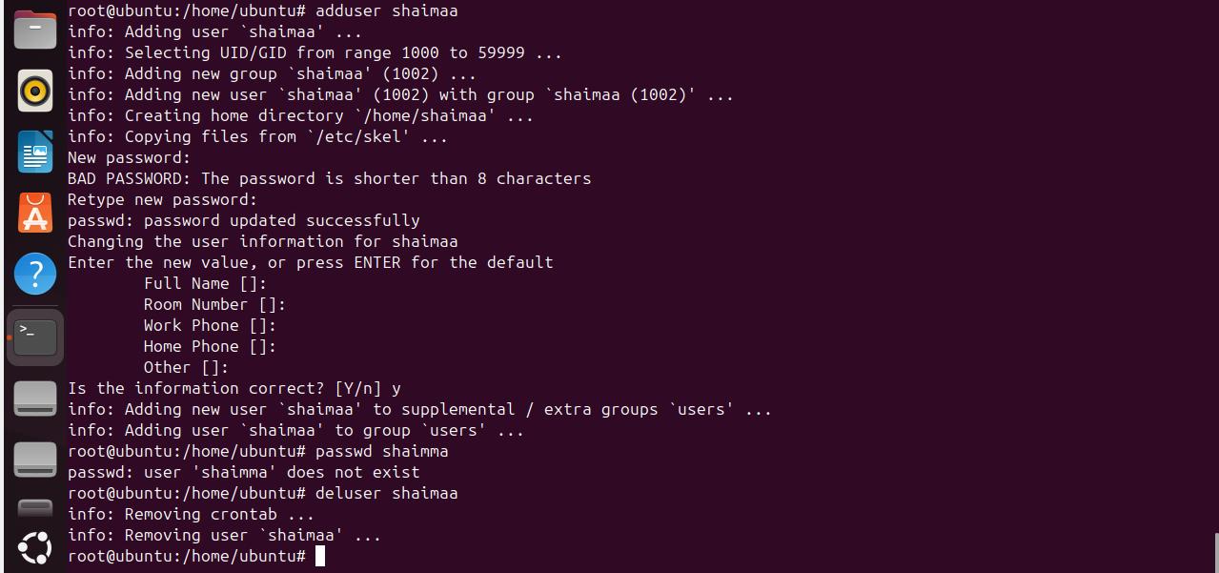

**Networking**

* ifconfig: Displays or configures network interfaces.

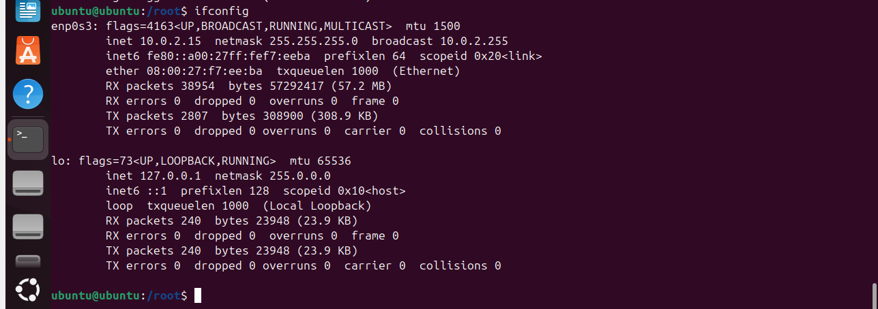

* ping [hostname/IP Adress]: Checks the connectivity to a host.

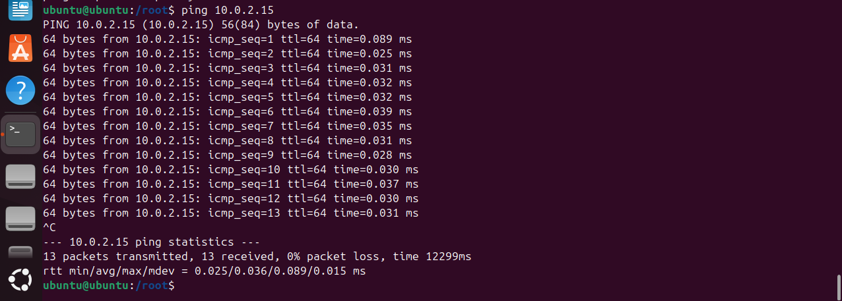

* netstat -tuln: Lists all listening ports and connections.

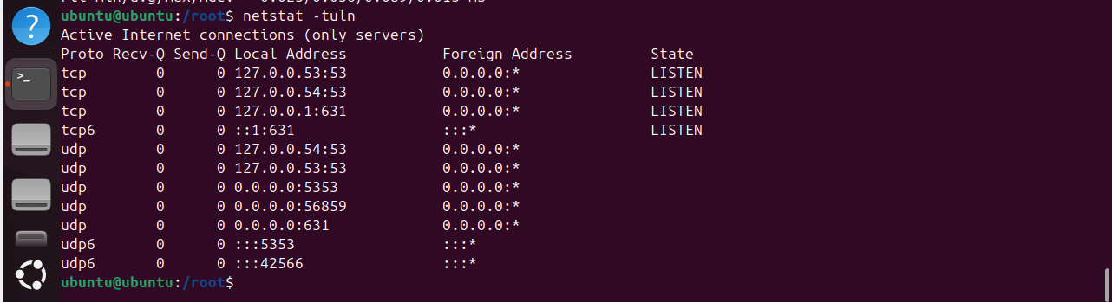

* ssh [user]@[host]: Connects to a remote host via SSH.

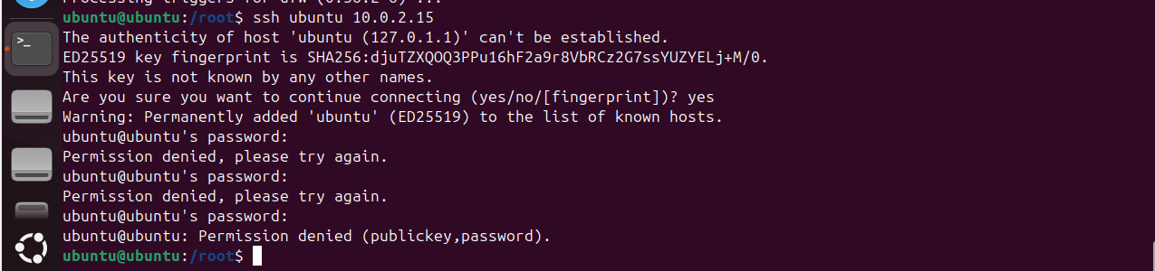

**Package Management**

* sudo apt install [package]: Installs a package.

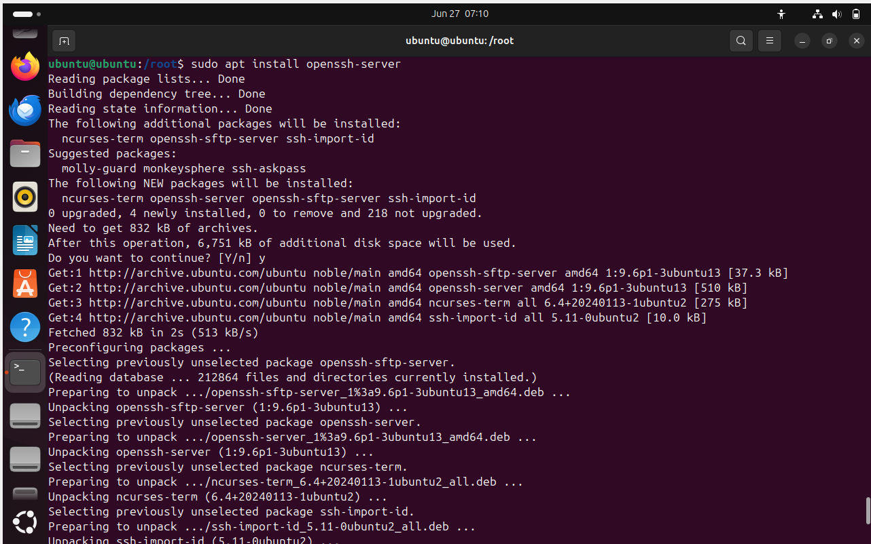

* sudo apt remove [package]: Removes a package.
* apt-cache search [package]: Searches for a package.

**System Information**

* uname -a: Shows system information.



* lsb_release -a: Displays distribution-specific information.

* hostnamectl: Shows or sets the system hostname.

**Process Management**

* ps aux: Lists all running processes.

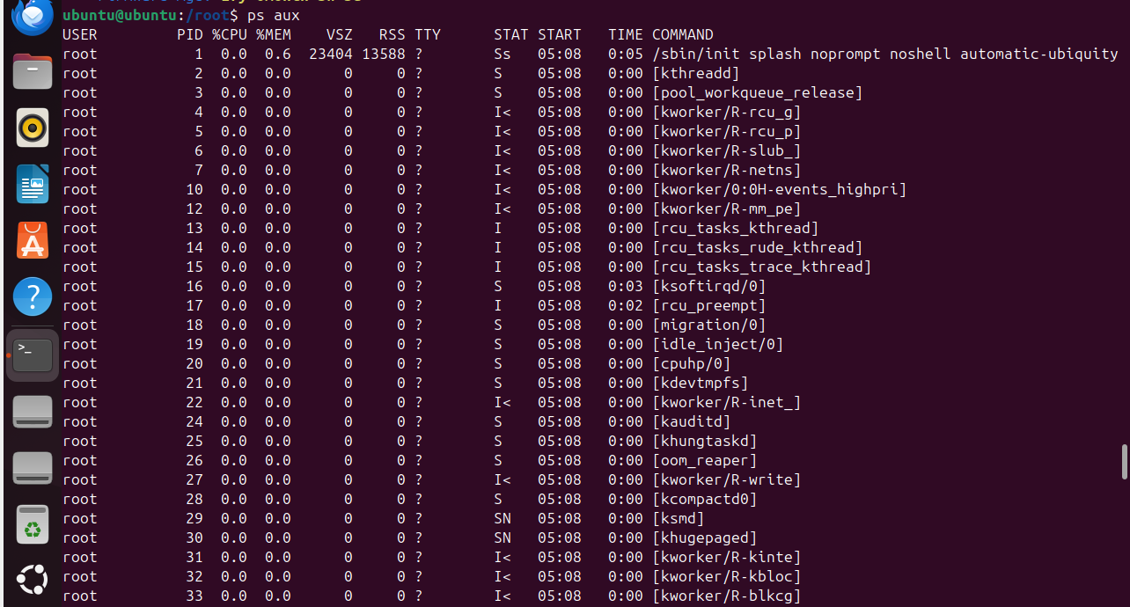

* kill [PID]: Terminates a process by its PID.

